

**Institute of Technology of Cambodia**

**Department of Information Communication Engineering**

**Subject: Internet Programming**

**Lecturer: HOK TIN**

**TP2: Basic JavaScript**

Name: Doeurn Sreynith

ID: e20190214

Group: GIC-A

**2022-2023**

# EX1:

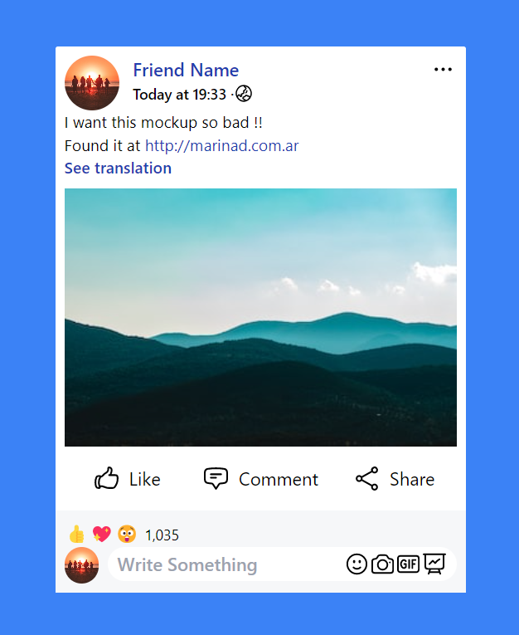

# Ex2:



# Ex3:

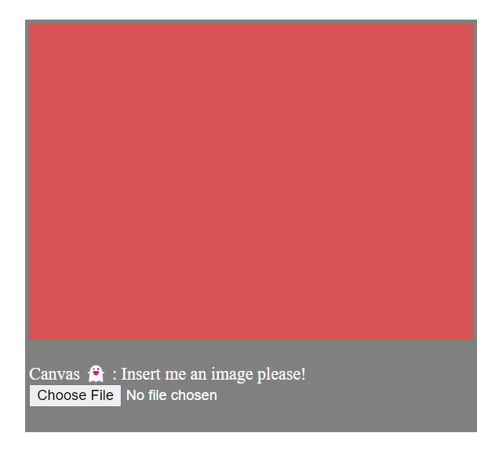

# EX4:

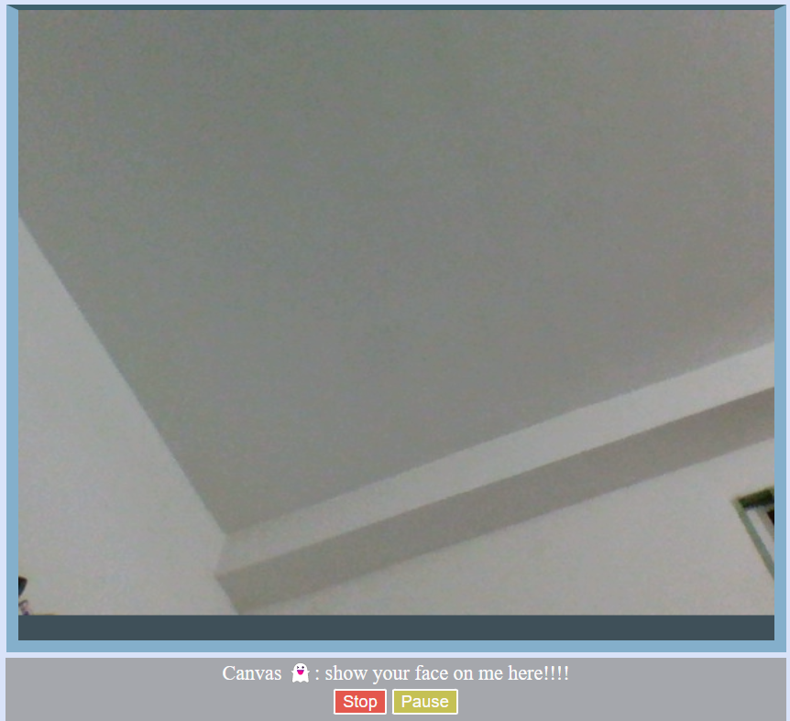

# EX5:

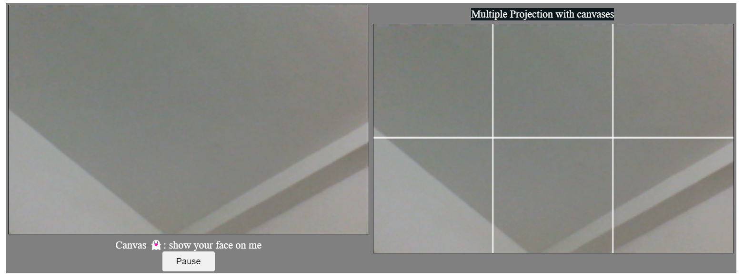

# EX6:

